1. Graphical user interface, application, Teams

   Description automatically generated

<h1>Welcome to Digital Library</h1>

<p>Create a new member</p>

<form action="/action_page.php">

  <label for="firstName">Name</label>

<input type="text" id="Name" name="Name"><br><br>

<label for="Email">Email</label>

<input type="text" id="Email" name="Email"><br><br>

  <label for="Password">Password</label>

<input type="text" id="Password" name="Password"><br><br>

  <label for="Phone number">Phone number</label>

<input type="Phone number" id="Phone number" name="Phone number"><br><br>

  <label for="freeform">Address

    <textarea id="freeform" name="freeform" rows="8" cols="35">

    </textarea><br><br>

  </label>

<br>

<legend>Gender:

    <input type="radio" name="gender" id="male" value="male" checked>

    <label for="male">Male</label>

    <input type="radio" name="gender" id="female" value="female">

    <label for="female">Female</label>

</legend>

<br><br>

  <input type="submit" value="Register">

</form>

Membuat html code dan mengcopy design yang di berikan di notion.

1. 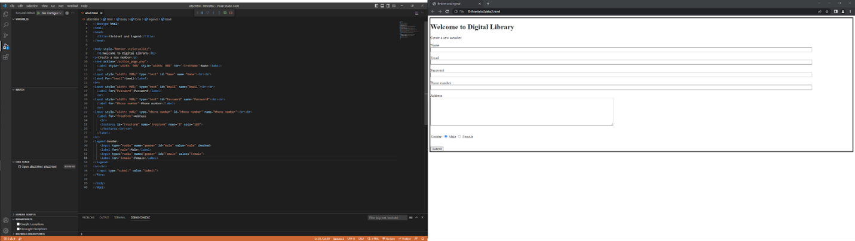

<!doctype html>

<html>

<head>

  <title>fieldset and legend</title>

</head>

<body style="border-style:solid;">

  <h1>Welcome to Digital Library</h1>

<p>Create a new member</p>

<form action="/action_page.php">

  <label style="width: 90%" style="width: 90%" for="firstName">Name</label>

  <br>

<input style="width: 90%;" type="text" id="Name" name="Name"><br><br>

<label for="Email">Email</label>

<br>

<input style="width: 90%;" type="text" id="Email" name="Email"><br><br>

  <label for="Password">Password</label>

  <br>

<input style="width: 90%;" type="text" id="Password" name="Password"><br><br>

  <label for="Phone number">Phone number</label>

  <br>

<input style="width: 90%;" type="Phone number" id="Phone number" name="Phone number"><br><br>

  <label for="freeform">Address

    <br>

    <textarea id="freeform" name="freeform" rows="8" cols="109">

    </textarea><br><br>

  </label>

<br>

<legend>Gender:

    <input type="radio" name="gender" id="male" value="male" checked>

    <label for="male">Male</label>

    <input type="radio" name="gender" id="female" value="female">

    <label for="female">Female</label>

</legend>

<br><br>

  <input type="submit" value="Submit">

</form>

</body>  
</html>

Membuat html code dan mengcopy design yang di berikan di notion.